4. Puzzle Mazes
Website : www.theedkins.co.uk/jo/u3acpatt
www.theedkins.co.uk/jo/maze

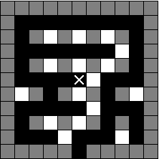
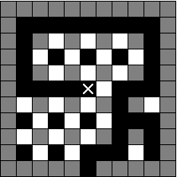
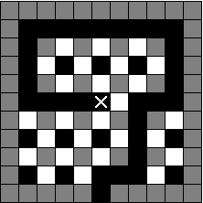
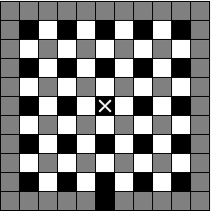
How to draw a branching maze
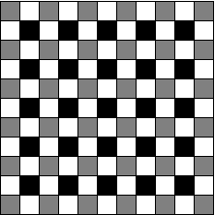
Solve by keeping one hand on wall (see white line). All walls connected. Path branches.
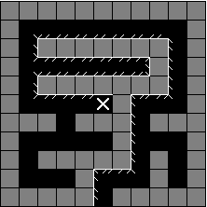
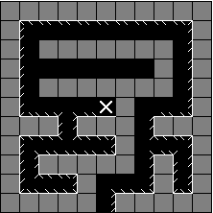
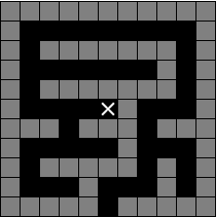

What is an island maze?
Same as a branching maze but with some holes in the wall!
Walls are not connected, but make different islands.
Sometimes you can’t solve this by keeping one hand on wall.
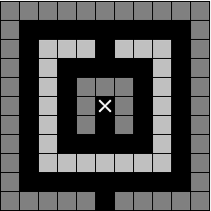
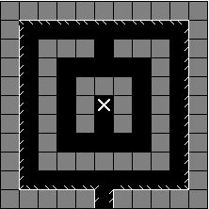
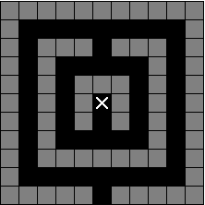

Examples:
Hampton Court maze, 1690
Bridge End Gardens maze at Saffron Walden, 1828
Mazes at Longleat. The biggest is modern, and is claimed to be the longest (but not the largest) hedge maze in the world. Covers 1.5 acres and over a mile of winding pathways.

Recommended book: Art of the Maze by Adrian Fisher

