6. Celtic knots II
Website : www.theedkins.co.uk/jo/u3acpatt
www.theedkins.co.uk/jo/knots
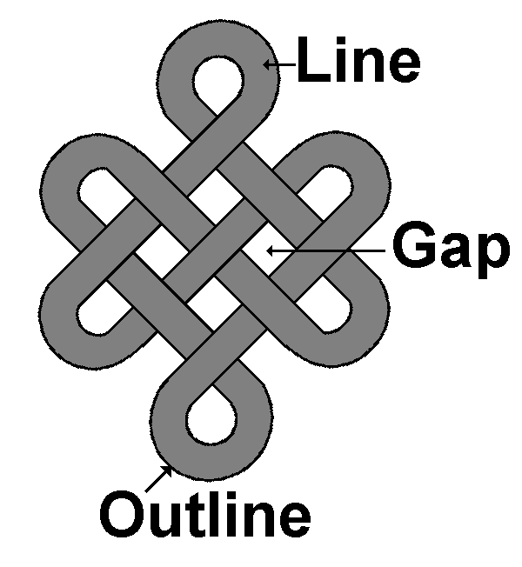
Names:

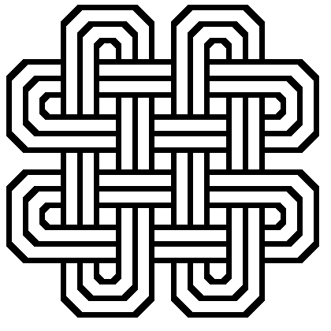
Double strand method:
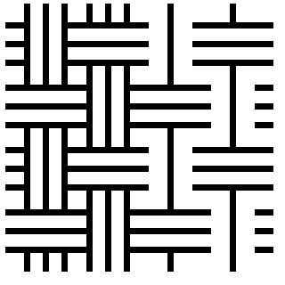
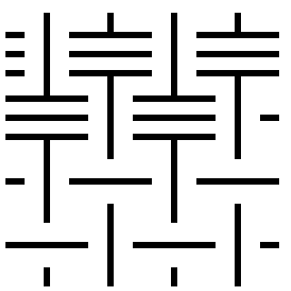
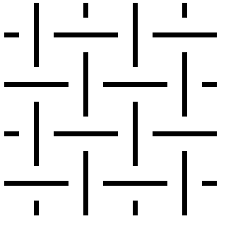
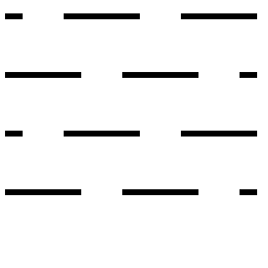

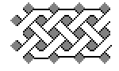
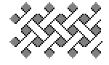
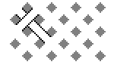


Gaps method: (known to be used in illuminated manuscripts)

Problems with junctions: sometimes an end gets tucked underneath somewhere!
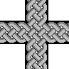
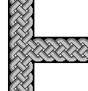
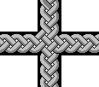
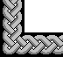
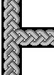

Correct name for Celtic knot pattern is interlace.
Islamic version (lines outlining geometric forms) is called girih.

Examples:
Roman mosaics: Fishbourne Palace & Verulamium 2C
Anglo-Saxon gold: Sutton Hoo & Staffordshire Hoard 7C
Stone: Scot, Manx, Anglo-Saxon, Irish 8-9C
Islamic girih patterns: 12-14C

