3. Unicursal Mazes
Website : www.theedkins.co.uk/jo/u3acpatt
www.theedkins.co.uk/jo/maze

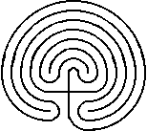
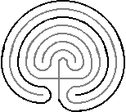
How to draw a Cretan or Classical maze
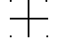
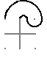
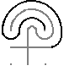
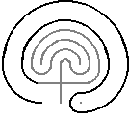

How to draw a Roman maze
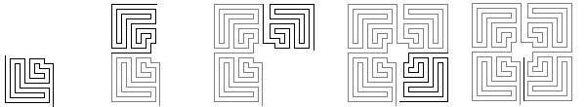

Roman maze types
serpentine double spiral meander complex meander

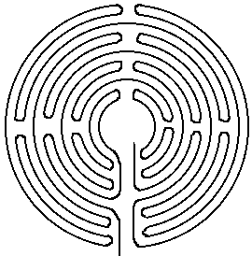
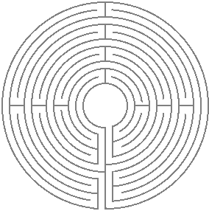
Chartres maze

Examples:
Oldest Cretan maze: on the back of clay accounting tablet at Pylos, Greece ~1200BC
Roman mazes: British examples from 100AD
Chartres mazes: on Chartres cathedral pavement 1235
Saffron Walden turf maze 1699

